# 27 June 2016

**Miling of Chromium coated SiN membrane.**

**Parameters :**

|  |  |
| --- | --- |
| Coating | 5 nm Cr |
| Thickness | 5 + 100 nm |
| Beam | 10µm – 1pA (6) |
| Area Dose | 20000 |
| Loop factor | 1 |
| Dot dose | 2.0088pC |
| Dot dwell time | 2813.445ms |
| Design | *Fp-triangle* |

**Results :**

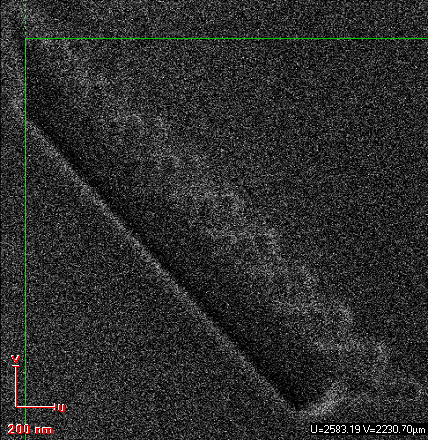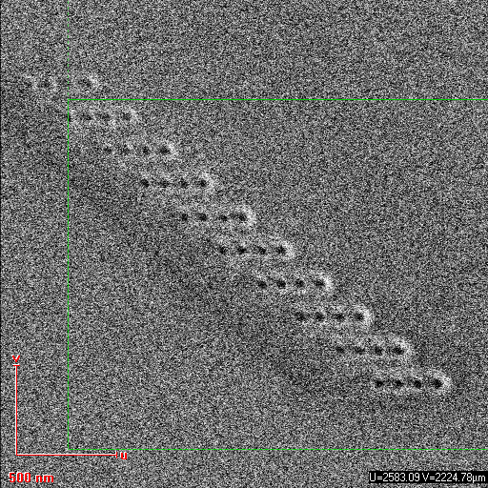I=0.714pA  
Triangle of fp-triangle at dose 10 does not pierce through the membrane. Maybe we weren’t on it because of the 50*50µm shift the software does.